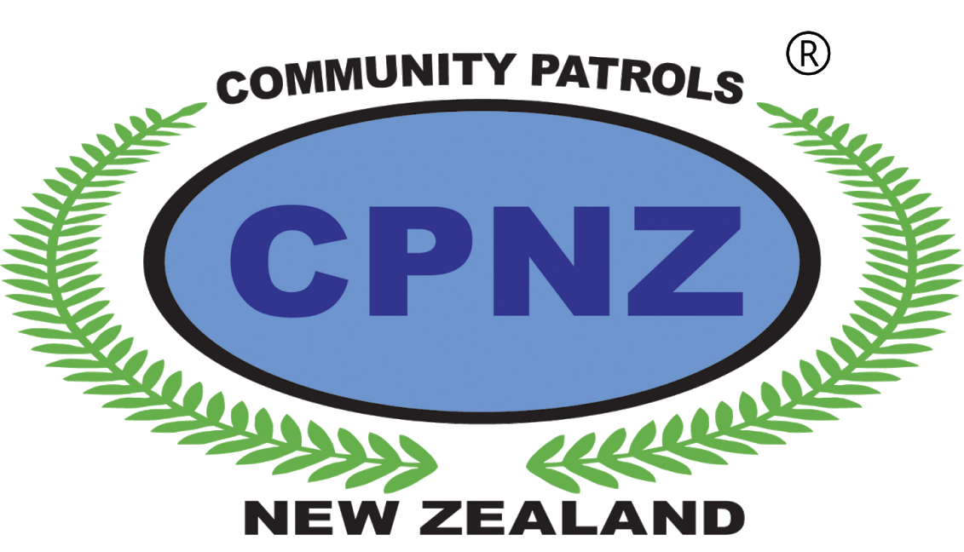 | COMMUNITY PATROLS  OF  NEW ZEALAND | Application to join  West Harbour CPNZ Community Patrol
Personal Details
Surname:
First Name:
Date of Birth:
Driver Licence:
Occupation:
Address:
Post Code:
Email:
Home Phone:
Mobile:

Please tell us why you would like to volunteer for this role.

__________________________________________________________________________________________________________________________________________________________________________________________________________________

Work Experience

1.__________________________________________________________________
2.__________________________________________________________________
3.__________________________________________________________________

Previous Volunteer Experience

1.__________________________________________________________________
2.__________________________________________________________________
3.__________________________________________________________________

Qualifications

1.__________________________________________________________________
2.__________________________________________________________________
3.__________________________________________________________________

Skills

1.__________________________________________________________________
2.__________________________________________________________________
3.__________________________________________________________________

Interests and Hobbies

1.__________________________________________________________________
2.__________________________________________________________________
3.__________________________________________________________________

Background information

Consideration of your acceptance to CPNZ will require you to undergo a Police Security Clearance check.

Are you aware of any information that may arise through the security checking process?
Please circle one: Yes / No

If yes, please provide details:

__________________________________________________________________________________________________________________________________________________________________________________________________________________

Do you have any special health requirements, medication, or disabilities that the Patrol Leader or those working with you should be aware of?

__________________________________________________________________________________________________________________________________________________________________________________________________________________
______________________________________________________________________

Emergency Contact Details
Please write down the name of a family member or friend who you would like to be contacted in the event of an emergency
Name
Address
Postcode
Phone
Relationship to you

References
Please supply the name and contact details of two referees.
Name
Address
Postcode
Phone
Relationship to you

Name
Address
Postcode
Phone
Relationship to you

I give my consent to CPNZ, the Police and the WEST HARBOUR COMMUNITY PATROL to make enquiries into my suitability as a volunteer and I authorise
any person approached by the Police in this matter to release or disclose all
information relevant to this application.

Signed: _________________________ Date: __________________________

